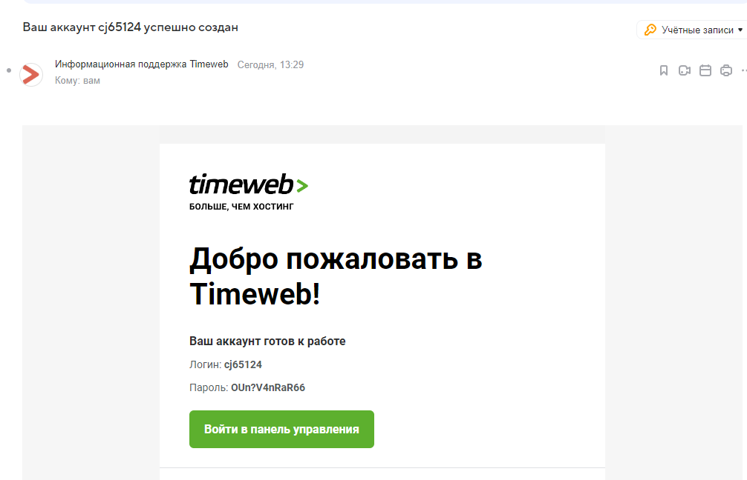

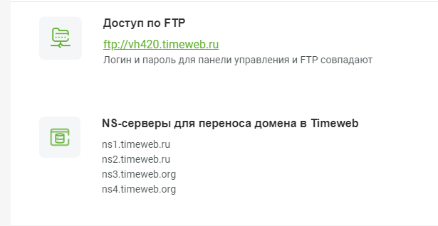

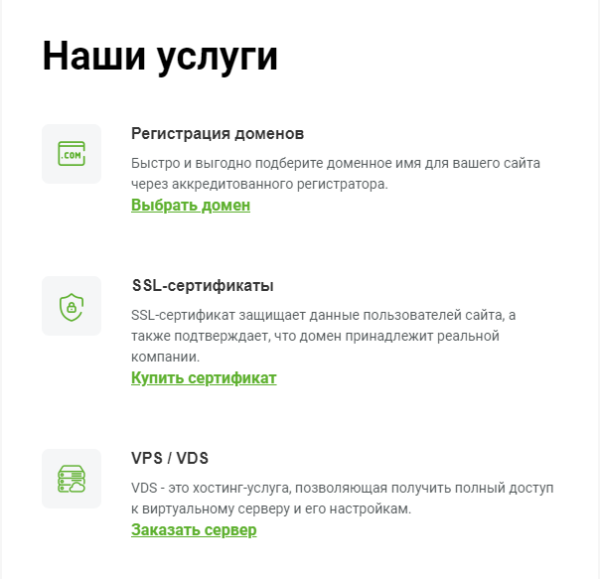

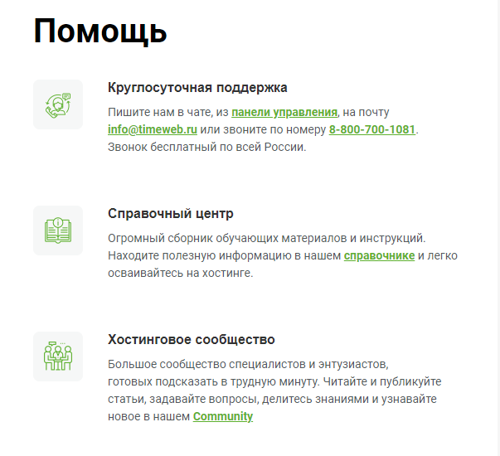

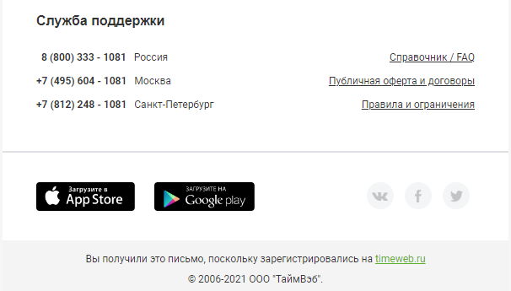

|  |  |  |  |  |  |  |  |  |  |  |  |  |  |  |  |  |  |  |  |  |  |  |  |  |  |  |
| --- | --- | --- | --- | --- | --- | --- | --- | --- | --- | --- | --- | --- | --- | --- | --- | --- | --- | --- | --- | --- | --- | --- | --- | --- | --- | --- |
| |  |  |  | | --- | --- | --- | | |  |  | | --- | --- | | |  | | --- | |  | | | | |  |  |  |  |  | | --- | --- | --- | --- | --- | | |  | | --- | | **Добро пожаловать в Timeweb!** | | **Ваш аккаунт готов к работе** | | Логин:**cj65124** | | Пароль: **OUn?V4nRaR66** | | | | |  |  |  |  | | --- | --- | --- | --- | | |  | | --- | | [**Войти в панель управления**](https://hosting.timeweb.ru/) | | |  | | --- | |  | | | | | |  |  | | --- | --- | | |  | | --- | |  | |  |  |  |  | | --- | --- | --- | | |  | | --- | | **Доступ по FTP** | | [ftp://vh420.timeweb.ru](ftp://vh420.timeweb.ru/) Логин и пароль для панели управления и FTP совпадают | | | | |  |  | | --- | --- | | |  | | --- | |  | |  |  |  |  | | --- | --- | --- | | |  | | --- | | **NS-серверы для переноса домена в Timeweb** | | ns1.timeweb.ru ns2.timeweb.ru ns3.timeweb.org ns4.timeweb.org | | | |

|  |  |  |  |  |  |  |  |  |  |  |  |  |  |  |  |  |  |  |  |  |  |  |  |  |  |
| --- | --- | --- | --- | --- | --- | --- | --- | --- | --- | --- | --- | --- | --- | --- | --- | --- | --- | --- | --- | --- | --- | --- | --- | --- | --- |
| |  |  |  |  | | --- | --- | --- | --- | | |  |  |  | | --- | --- | --- | | |  |  | | --- | --- | | |  | | --- | |  | | | | | |  |  | | --- | --- | | |  | | --- | | **Наши услуги** | | | | |  |  | | --- | --- | | |  | | --- | |  | |  |  |  |  | | --- | --- | --- | | |  | | --- | | **Регистрация доменов** | | Быстро и выгодно подберите доменное имя для вашего сайта через аккредитованного регистратора. [**Выбрать домен**](https://hosting.timeweb.ru/domains/registration) | | | | |  |  | | --- | --- | | |  | | --- | |  | |  |  |  |  | | --- | --- | --- | | |  | | --- | | **SSL-сертификаты** | | SSL-cертификат защищает данные пользователей сайта, а также подтверждает, что домен принадлежит реальной компании. [**Купить сертификат**](https://hosting.timeweb.ru/ssl#order) | | | | |  |  | | --- | --- | | |  | | --- | |  | |  |  |  |  | | --- | --- | --- | | |  | | --- | | **VPS / VDS** | | VDS - это хостинг-услуга, позволяющая получить полный доступ к виртуальному серверу и его настройкам.  [**Заказать сервер**](https://timeweb.com/ru/services/vds/) | | | |

|  |  |  |  |  |  |  |  |  |  |  |  |  |  |  |  |  |  |  |  |  |  |  |  |  |  |  |  |  |  |
| --- | --- | --- | --- | --- | --- | --- | --- | --- | --- | --- | --- | --- | --- | --- | --- | --- | --- | --- | --- | --- | --- | --- | --- | --- | --- | --- | --- | --- | --- |
| |  |  |  |  | | --- | --- | --- | --- | | |  |  |  | | --- | --- | --- | | |  |  | | --- | --- | | |  | | --- | |  | | | | | |  |  | | --- | --- | | |  | | --- | | **Помощь** | | | | |  |  | | --- | --- | | |  | | --- | |  | |  |  |  |  | | --- | --- | --- | | |  | | --- | | **Круглосуточная поддержка** | | Пишите нам в чате, из [**панели управления**](https://hosting.timeweb.ru/support), на почту [**info@timeweb.ru**](https://e.mail.ru/compose/?mailto=mailto%3ainfo@timeweb.ru) или звоните по номеру [**8-800-700-1081**](tel:8-800-700-1081). Звонок бесплатный по всей России. | | | | |  |  | | --- | --- | | |  | | --- | |  | |  |  |  |  | | --- | --- | --- | | |  | | --- | | **Справочный центр** | | Огромный сборник обучающих материалов и инструкций. Находите полезную информацию в нашем [**справочнике**](https://timeweb.com/ru/help/pages/viewpage.action?pageId=1245198)и легко осваивайтесь на хостинге. | | | | |  |  | | --- | --- | | |  | | --- | |  | |  |  |  |  | | --- | --- | --- | | |  | | --- | | **Хостинговое сообщество** | | Большое сообщество специалистов и энтузиастов, готовых подсказать в трудную минуту. Читайте и публикуйте статьи, задавайте вопросы, делитесь знаниями и узнавайте новое в нашем **[Сommunity](https://timeweb.com/ru/community" \t "_blank)** | | | | |  |  |  | | --- | --- | --- | | |  |  | | --- | --- | | |  | | --- | |  | | | | |

|  |  |  |  |  |  |  |  |  |  |  |  |  |  |  |  |  |  |  |  |  |  |  |  |  |
| --- | --- | --- | --- | --- | --- | --- | --- | --- | --- | --- | --- | --- | --- | --- | --- | --- | --- | --- | --- | --- | --- | --- | --- | --- |
| |  |  |  |  |  |  |  |  |  |  |  | | --- | --- | --- | --- | --- | --- | --- | --- | --- | --- | --- | | |  |  |  |  |  | | --- | --- | --- | --- | --- | | |  | | --- | | **Служба поддержки** | | **8 (800) 333 - 1081**Россия | | **+7 (495) 604 - 1081**Москва | | **+7 (812) 248 - 1081**Санкт-Петербург | |  |  |  |  |  |  | | --- | --- | --- | --- | --- | | |  | | --- | |  | | [Справочник / FAQ](https://timeweb.com/ru/help/pages/viewpage.action?pageId=1245198) | | [Публичная оферта и договоры](https://timeweb.com/ru/support/documents/) | | [Правила и ограничения](https://timeweb.com/ru/services/hosting/rules/) | | | | |  | | --- | |  | | | |  |  |  | | --- | --- | --- | | |  | | --- | |  | |  |  |  |  | | --- | --- | | |  | | --- | |  | |  |  |  |  |  |  | | --- | --- | --- | --- | --- | | |  |  |  |  | | --- | --- | --- | --- | | |  |  |  | | --- | --- | --- | | [VK](https://goo.gl/HKsJA6) | [Fb](https://www.facebook.com/TimeWeb) |  | | | | |